Main Title

Abstract. The abstract consist of a 250-word paragraph mentioning objectives, methods or main analysis, and conclusion or main argument. It is followed by 3-5 keywords.

Keywords. Keyword 1, keyword 2, keyword 3, keyword 4.

Introduction

Manuscripts should be written on A4 size paper with the following margins: 4 cm (top), 3 cm (right), 3 cm (bottom), and 3 cm (left). The manuscript’s length, including tables and illustrations, should be between 10-20 pages or 4,000-8,000 words. One illustration is approximately equal to one half page or 200 words.

Paragraphs are single-spaced with full justification. They begin with a left indent and are separated by one single-spaced blank line.

The body of the paper can be divided into three basic elements, which are introduction, main content, and conclusion. The introductory section strategically presents the context, significance, focus, and organization of the paper. If necessary, notes of methodological issues can be made in a separate section.

The main content

There is no standardized requirement on how the main content is organized. However, we expect the author to divide it into several sections indicating literature review and analytical results and discussions.

Subheading/ subchapter

Tables and figures are inserted on the relevant page and cited in the main text as follows: “(Table 1)”. The table titles are placed above the tables and the figure titles are put at the bottom of the figures. Every table and figure is numbered consecutively starting from 1 (Latin).

Table 1. Table Lable

Column title 1 | Column title 2 | Etc..
Column content 1 | .. | ..
Etc.. | .. | ..

Please make sure that all figures and illustrative materials are original works of the author(s) or provided with written permission from the copyright holders. The editors may automatically exclude those have the potentials to infringe copyright from the manuscripts.

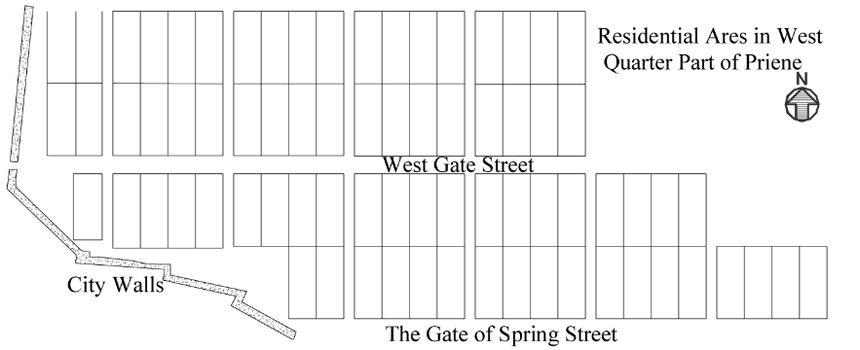

Figure 1. Figure Lable

Footnotes are allowed (with a maximum of 3) and placed at the bottom of the relevant page and ordered using Latin numbering.

Citations give the author’s last name and the year of publication, with at least the year placed in parentheses, for instance: “…(Albrechts, 2014)…” or “According to Albrechts (2014)…”. Direct quotations have opening and closing quotation marks (“...”) and are accompanied by the page numbers where they are located in the original source, for example: (Tirtosudarmo, 2013, p. 101). Citations of two or more sources are separated by a semicolon (;), for example: (Healey, 2007; Innes and Booher, 2009). If a cited source is written by more than three authors only the first author should be given while the rest are replaced by “et al.”, for example: (Firman et al., 2013). Should the author be unknown or anonymous, then the author’s name can be replaced with the name of the institution or publisher, for example: (Kompas, 2014). Tertiary citations, for example, “According to Foucault (1996, in Dinda, 2014) ...” should be avoided completely.

Conclusion

Finally, the concluding section must revisit the focus of the paper and highlights key findings and further remarks or wider implications for theoretical and/ or professional knowledge development.

References

Benyamin, Y. (2012) Kajian Kelembagaan Penyelesaian Konflik Batas Laut Daerah. The thesis of Geodesy Engineering. Bandung Institute of Technology.
Hoffman, M., S. Hayes, dan M. Napolitano (2014) Urban Youths’ Experiences and Perceptions of a Community Cycling Initiative. Planning Theory 51(2), 300-318.
Kraas, F. et.al. (Ed.) (2013) Megacities: Our Global Urban Future. Dordrecht: Springer.
Rosly, D., N. Puzi, dan M. Arshad (2012) Planning Strategies, Guidelines and Action Plan for Green Neighbourhoods in Malaysia. Paper presented at EAROPH Congress: Green Cities for Human Betterment, Daegu, 10-17 October
Rusunawa di Tasik Dibangun Kemenpera untuk Santri. Kompas, 14 January 2014.
Siregar, A. (2014) Indonesian Summit Diplomacy in 2013. The Jakarta Post, 10th January. Retrieved from http://www.thejakartapost.com/ news/2014/01/10/ indonesian-summit-diplomacy-2013.html on 14th January 2014.
Tirtosudarmo, R. (2013) Urbanization without Development: The Cases of Cirebon and Gresik on Java’s North Coast. Dlm: Bunnell, T., Parthasarathy & E. Thompson (Ed.) (2013) Cleavage, Connection and Conflict in Rural, Urban and Contemporary Asia, pp. 99-115. Singapore: Springer.
Yin, J. (2012) Urban Planning for Dummies. Mississauga: John Wiley & Sons.

